Board of Review Guidelines for Scouts

The Purpose of a Board of Review is:

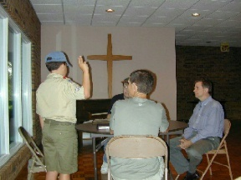
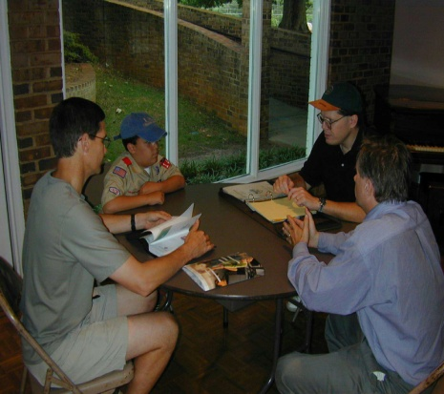
* To make sure you have completed the requirements for the rank.
* To see how good an experience you are having in the unit.
* To encourage you to progress further.
The Board is interested in your attitudes, accomplishments and acceptance of Scouting's ideals. The Board also wants you to tell them what is good about the troop and what needs improvement in the troop.
The Board of Review is NOT a retest; however, the Board will check to make sure that all the requirements have been "signed off" in your handbook and that the records are consistent with the requirements for the rank.
You must wear your full uniform, be neat and your uniform must be as correct as possible, with the badges worn properly. The merit badge sash is not required for Tenderfoot, Second Class, or First Class Boards of Review, but is required for Star, Life, and Eagle.
You will be introduced to the Board. You might be asked to stand at attention and recite the Scout Law, Scout Oath, Scout Motto, Scout Slogan and/or Outdoor Code. You should know them and understand their meaning.
The Board will then ask you questions. The questions will offer you an opportunity talk about your opinions, experiences, activities, and accomplishments. The questions may not be restricted to Scouting topics; questions regarding home, church, school, work, athletics, etc. are all appropriate.
Sometimes difficulties at home, school or elsewhere make certain discussions unpleasant for a Scout. Scouts, their parents, guardians or others should inform either the Scoutmaster or the Advancement Chairperson of any such difficulties before the Board of Review so that they can avoid the topic.
The Board of Review is similar to many situations that adults deal with in their everyday lives, such as job interviews or negotiations with individuals in authority. As you go progress through the ranks, you will participate in many Boards of Review and your confidence in yourself and the review process will grow. You are "selling" yourself to the Board and want to present your best appearance. There are three steps you should follow in order to present yourself at your best:
1. Review all work you have done in order to qualify for the Board of Review.
2. Think about what the work really means - how it applies to your life now and in the future - how the Scout law, oath, motto, slogan, and outdoor code affect your life - about where you are going....
3. Interact with the Board with confidence. Stand or sit upright and in a dignified position. Make eye contact with the members of the board. Speak clearly and with enough volume that you sound confident - even if the answer is "I don't know."
When all members have had an opportunity to ask their questions, you will be excused from the room. The Board will discuss your progress toward your next rank and decide whether you have met all the requirements. The Board will then invite you back into the room and inform you of their decision.
If there is some reason that the Board does not feel that you are ready to advance to the next rank, the Board will tell you what areas you need to work on in order to successfully complete the Board of Review. You and the board will determine a time for a subsequent Board of Review. The Chairman of Advancement will send a written follow up to you and the Scoutmaster outlining the deficiencies and the course of action to correct them.

Boards of Review for Tenderfoot Rank:
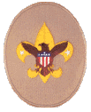
The Board will want to know how well you are fitting into the troop and how much you are enjoying being a Scout. They might ask questions about Scout skills you have learned.
This is your first Board of Review and you might be nervous. Take a deep breath and relax. The Board is on your side.
The Board can ask any question they feel is appropriate, but you can expect questions like:
1. What are some of the things you have done since joining the troop?
2. What camping trips have you been on and how might the things you learned there help you in life?
3. How would you treat a first degree burn?
4. What does the Scout slogan mean to you?
5. What do you expect to get from being Scout?

Boards of Review for Second Class Rank:
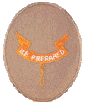
Scout skills are emphasized at this stage of Scouting and questions will often center on the use of skills learned as a Scout. The Board might ask questions about how the Scout's patrol is functioning, and how this Scout is functioning within his patrol.
The Board can ask any question they feel is appropriate, but you can expect questions like:
1. How many troop or patrol activities have you participated in during the last 3 months?
2. What did you learn while working on a service project? Did you have a good time?
3. Why is it important to know first aid?
4. How did you learn about using a map and compass?
5. Have you earned any merit badges? Which ones have you earned? Why did you choose them?
6. What suggestions do you have for improving our Troop?
7. How do you observe the Outdoor Code when hiking or camping?
8. When do you expect to complete the requirements for 1st Class?

Boards of Review for First Class Rank:
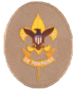
A First Class Scout has learned a lot of skills that will help him throughout his life. Reaching the rank of First Class also opens up additional opportunities such as Order of the Arrow, leadership positions, etc.
The First Class Scout should also feel an additional sense of responsibility to the troop and his patrol.
The Board can ask any question they feel is appropriate, but you can expect questions like:
1. On average, how many Troop meetings do you attend each month?
2. What part of Troop meetings are most rewarding to you? Most troubling?
3. Tell us about your last campout with the Troop. How was the duty roster prepared? How well did the duty roster work?
4. Why do you think that first aid is emphasized in Scouting?
5. What does it mean to say, "A Scout is Thrifty"?
6. Why are merit badges a part of Scouting?
7. How do you define "Scout Spirit"?
8. What do you know about Order of the Arrow?
9. When do you think you might be ready for Star Scout?

Boards of Review for Star Rank:
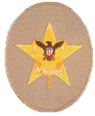
With the Star rank, emphasis is placed upon service to others, merit badges, and leadership. Scout skills remain an important element for the Star Scout; however, the emphasis should be on teaching other Scouts these skills.
The Board can ask any question they feel is appropriate, but you can expect questions like:
1. How many Troop outings have you attended in the last three months?
2. Tell us about your service project.
3. How have the Scout skills that you have learned helped you in a non-Scouting activity?
4. How many merit badges have you earned? What was the most difficult? Fun?
5. What leadership positions have you held outside of your patrol? What challenges did they present? What are your personal leadership goals and objectives?
6. How would you get a Scout to do an unpleasant task?
7. What extracurricular activities do you participate in at school?
8. How are the Scout Oath and Law part of your daily life?
9. When do you plan on achieving the Life rank?

Boards of Review for Life Rank:
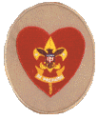
The Life rank is the final rank before Eagle. The Life Scout should be fully participating in the Troop, with emphasis being placed on leadership in the unit, as well as teaching skills and leadership to the younger Scouts. Merit Badge work should be a regular part of the Scout's career. Scouting values and concepts should be an integral part of the Scout's daily life.
At this point, the Scout is starting to "give back to Scouting" through leadership, training of other Scouts, recruiting, keeping Scouts active in the program, etc.
The Board can ask any question they feel is appropriate, but you can expect questions like:
1. What has been your worst camping experience in Scouting? Why? How could it have been improved?
2. Have any of the merit badges you have earned lead to hobbies or possible careers?
3. What are your special interests?
4. Why do you think that certain merit badges are required for the Eagle Rank?
5. What is your current (most recent) leadership position within the Troop? How long have you held that position? What particular challenges does it present? What is Leadership?
6. Do you have any brothers or sisters who are in Scouts (any level)?
What can you do to encourage them to continue with Scouts, and to move forward along the Scouting Trail?
7. How do you benefit from performing service projects?
8. The Scout Oath refers to "Duty to Self"; what duty do we have to ourselves?
9. Have you begun to think about an Eagle Service Project? What are you thinking about doing? When?

